Central Virginia


Beekeepers Association

Pres. Brian Gallagher - 978-4405 brian.j.gallagher@comcast.net
Treas. Art Freeman 540-456-6219 nameerftra@yahoo.com
Sec. Faith Andrews Bedford - 295-3823 faithab@aol.com
County Fair Coord. Ken Hall - 973-0807 ken.hall@gefanuc.com
Events Coord. Dana Tornabene - 974-1431 dana.tornabene@gmail.com
Newsletter – Brian Gallagher

June 2009

June 4th Meeting

For June the speaker will be John McGhee, our area’s state be
e inspector. John will give us an update on beekeeping around Virginia.

See you at the Ivy Creek Natural Area on Thursday, June 4th at 7:00 PM.

Directions to Ivy Creek Natural Area: http://ivycreekfoundation.org/located.html

Programs

If you have ideas for meeting topics you would like to see covered, let Dana Tornabene know. Remember, no meeting in July, we will have the honey tasting instead.

This Month’s Beekeeping

The honey/nectar flow is on but the unusually cool weather hasn’t helped. I expect we will make a lot less honey than average but maybe the bees know better. Remember to keep at least one empty super beyond what they are filling, on your hives. They use the extra room to store nectar and evaporate the water, and then take that honey down for storage below.

Several members have called with swarms. You should check all hives for swarm cells now and take appropriate steps if you find them. http://maarec.cas.psu.edu/pdfs/Swarm_Prev_Control_PM.pdf
If you find supercedure cells on the face of the comb it means the bees have decided to replace the queen. I leave them as the bees know something is wrong and I don’t want to be left with a failing queen.
Attached as the last page is the weight chart for the hive that I have on a scale. I think the weight gain is later this year but attribute it to the early cool weather.

The CVBA Clothing Logo Program

Emma Fauss and Art Freeman are proceeding on the Logo and clothing project. At the last meeting we selected the final logo. Art ordered a sample and Emma will let us see it at the June meeting. We can then decide what clothing we want to order.
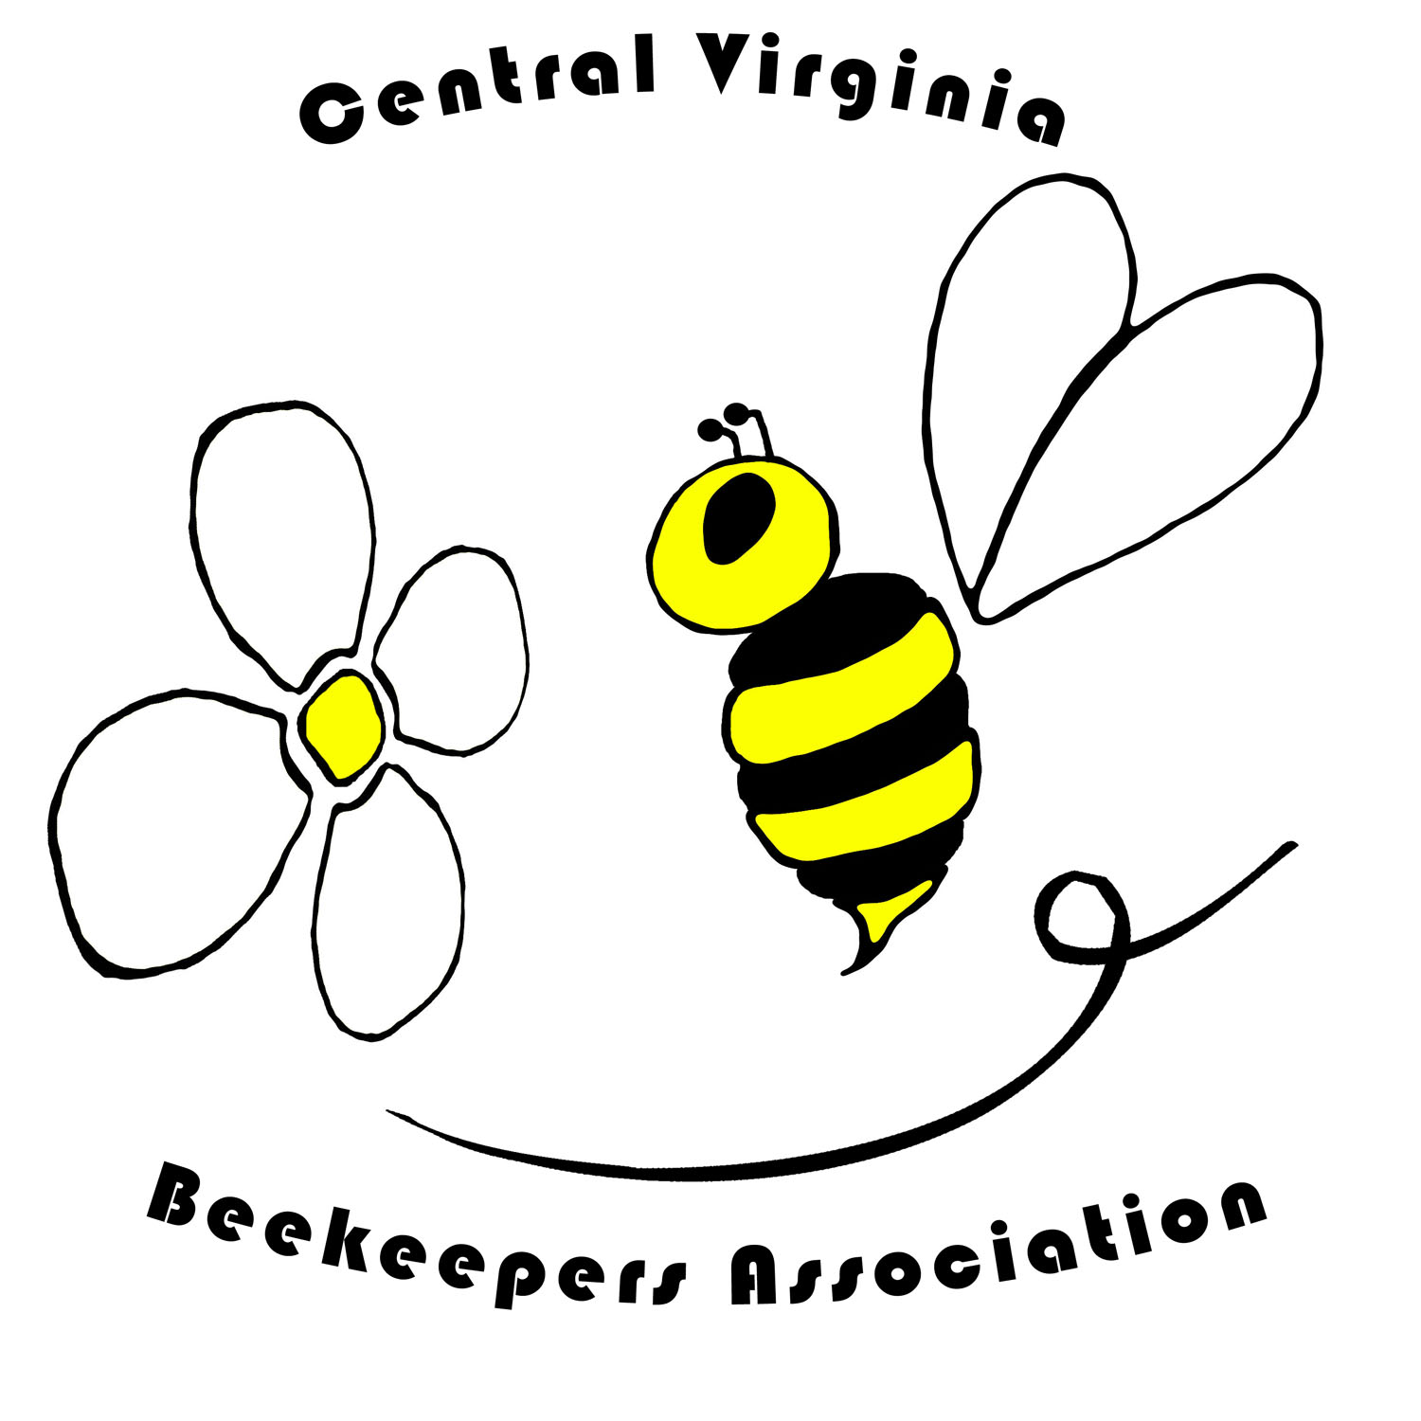 | 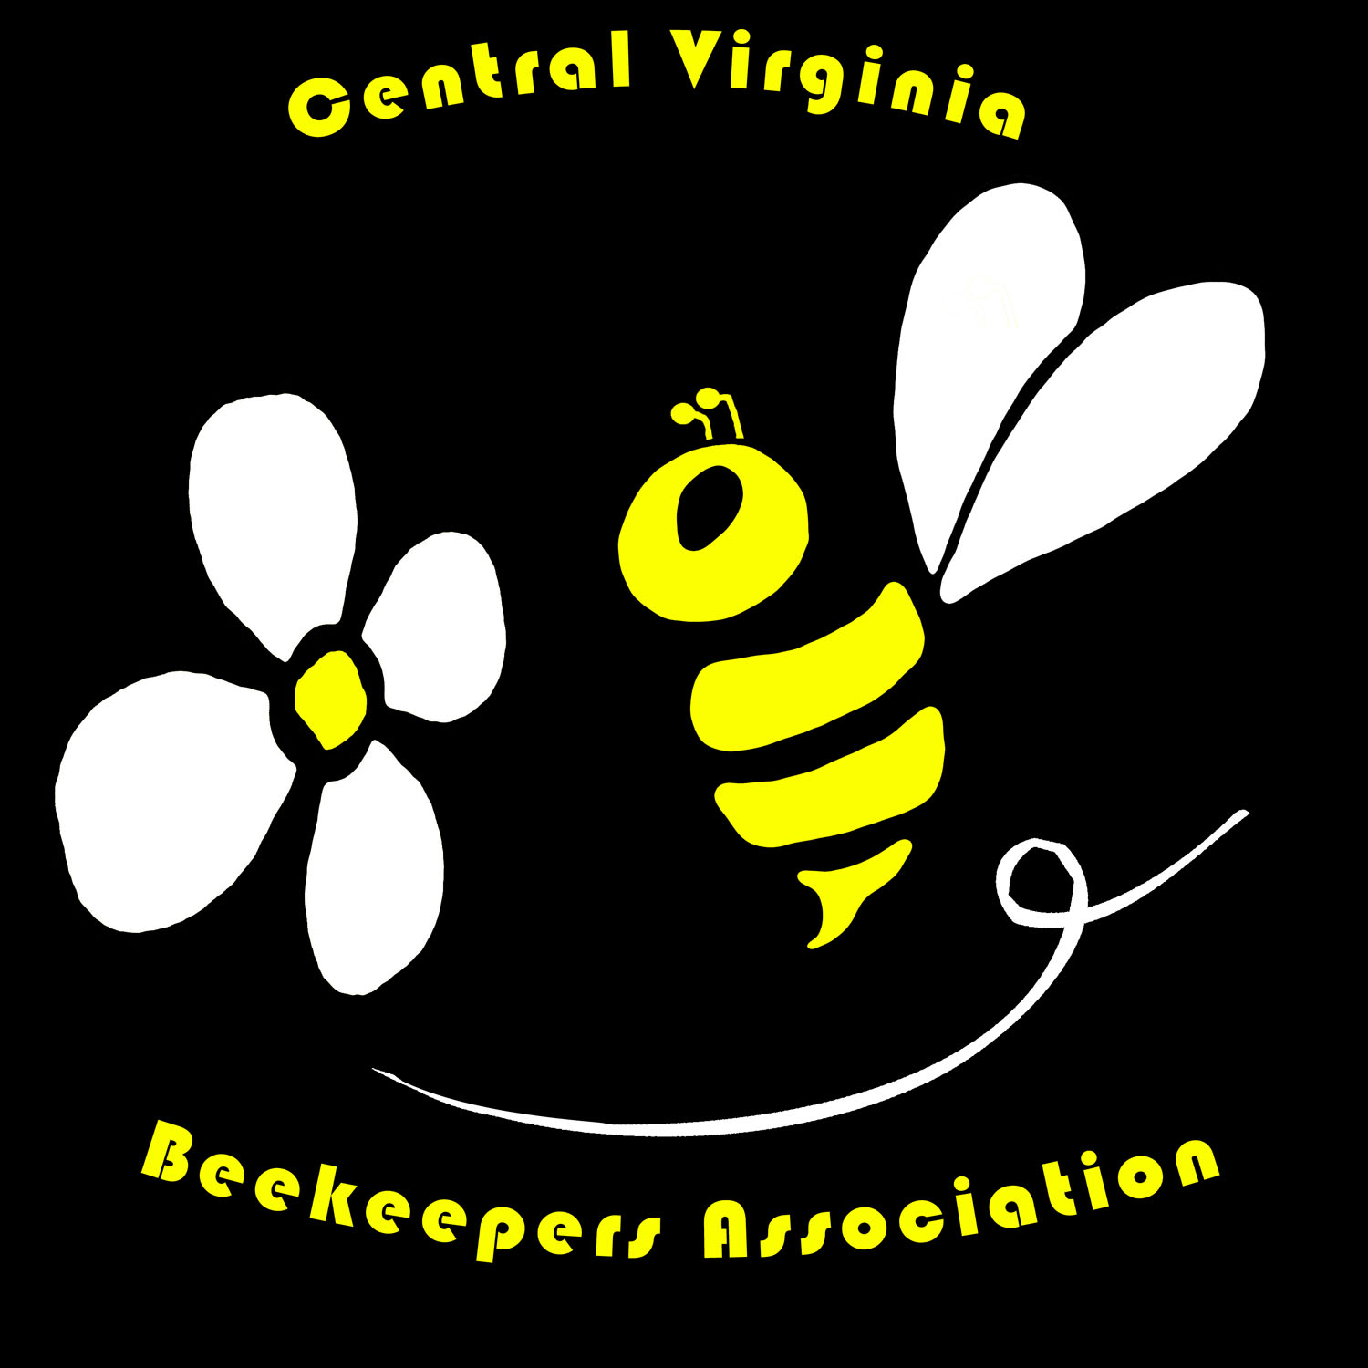

Beehives Wanted

Two people have called asking for a Beekeeper to put a hive on their property.

Patty Swygert lives on Lawson Lane off Markwood Road in Earlysville. She has 90 acres and is looking for pollination of her garden. Call 973-3229 if you are interested.

Phil Storey lives in the Woolen Mills area of Charlottesville and is also looking for pollination. He can be reached at 996-7591.

THE BEEKEEPERS Richard Knox Robinson
A short documentary film about Beekeepers will be shown at the Vinegar Hill Theater on Sat. June 13 at 1:30PM along with two others. There will be a local screening of The Beekeepers as part of the Look3 Festival of the Photograph in Charlottesville at the Vinegar Hill Theater. The Beekeepers premiered at Sundance, screened last week in Toronto as part of the Hot Docs Documentary Film Festival and will screen next week in Telluride as part of the Mountain Film Festival. At the Atlanta Film Festival, The Beekeepers won the jury prize for Best Short Documentary. The photographer used local Beekeepers Kathy Miller and Brian Gallagher in making the film.

Contacts

Our Bee Experts that you might want to contact at times are:

Keith Tignor, State Apiarist, Richmond, 804-786-3515 Keith.Tignor@vdacs.virginia.gov

John McGhee, Bee Inspector, Harrisonburg, 540-209-9153
John.McGhee@vdacs.virginia.gov

A Beekeeper’s Calendar

So that you can mark your calendar ahead, and keep the following dates free for these important happenings, we’re going to include this calendar with every newsletter. More detailed announcements will be included in each month’s edition. The meetings of the CVBA are on the first Thursday of the month at Ivy Creek Natural Area at 7:00 PM, unless announced otherwise, from March through November.

June 4 - CVBA Meeting at Ivy Creek Natural Area, 7:00 PM

July 18 - Annual Honey Tasting, Saturday at Ivy Creek (No July Meeting)
(Club members only)

July 27 - Bring Honey entries to the County Fair

July 28 - Aug 2 - Albemarle County Fair
http://www.albemarlecountyfair.com/

Aug 3-7 - Eastern Apicultural Society meeting, Ellicottville, NY
http://www.easternapiculture.org/

Aug. 6 - No Meeting because of the County Fair

Sept. 3 - CVBA Meeting at Ivy Creek Natural Area, 7:00 PM

Nov. 7 - VSBA Fall Meeting, Blue Ridge Com. College, Weyers Cave, VA
http://www.virginiabeekeepers.org/

Hope to see all of you at a meeting soon.

Bee Hive Weight - Summer 2009
Day | Date | Weight (lbs.) | Gain/Loss | High °F | Comments
Sat. | 4/25/09 | 127.0 |  | 91 | 3 Deep Brood Boxes
Sun. | 4/26/09 | 128.5 | 1.5 | 89 | .26" Rain
Mon | 4/27/09 | 130.5 | 2.0 | 87
Tues | 4/28/09 | 132.0 | 1.5 | 84
Wed. | 4/29/09 | 132.0 | 0.0 | 65 | .17" Rain
Thurs. | 4/30/09 |  |  | 58
Fri. | 5/1/09 |  |  | 76 | .01"
Sat. | 5/2/09 |  |  | 73 | .03"
Sun. | 5/3/09 |  |  | 58
Mon | 5/4/09 |  |  | 61 | .96" Rain
Tues | 5/5/09 |  |  | 58 | .24"
Wed. | 5/6/09 | 143.5 | 11.5 | 60 | 1.19" Rain
Thurs. | 5/7/09 | 169.0 |  |  | Added 2 supers of drawn comb
 | 5/7/09 | 171.0 | 2.0 | 79 | .24"
Fri. | 5/8/09 | 174.0 | 3.0 | 78 | .07"
Sat. | 5/9/09 | 177.5 | 3.5 | 85
Sun. | 5/10/09 | 180.5 | 3.0 | 75
Mon | 5/11/09 | 181.0 | 0.5 | 60 | .27"
Tues | 5/12/09 | 183.5 | 2.5 | 69
Wed. | 5/13/09 | 188.5 | 5.0 | 72
Thurs. | 5/14/09 | 198.0 | 9.5 | 74
Fri. | 5/15/09 | 202.5 | 4.5 | 76
Sat. | 5/16/09 | 209.0 | 6.5 | 81 | 1.15"
Sun. | 5/17/09 | 210.0 | 1.0 | 63 | .03"
Mon | 5/18/09 | 209.5 | -0.5 | 64
Tues | 5/19/09 | 211.5 | 2.0 | 68
Wed. | 5/20/09 | 215.5 | 4.0 | 75
 | 5/20/09 | 227.0 |  |  | Added 1 super of drawn comb
Thurs. | 5/21/09 | 233.5 | 6.5 | 80
Fri. | 5/22/09 | 241.5 | 8.0 | 83
Sat. | 5/23/09 | 249.5 | 8.0 | 82
Sun. | 5/24/09 | 259.5 | 10.0 | 78
Mon | 5/25/09 | 269.5 | 10.0 | 79 | .09"

