Central Virginia
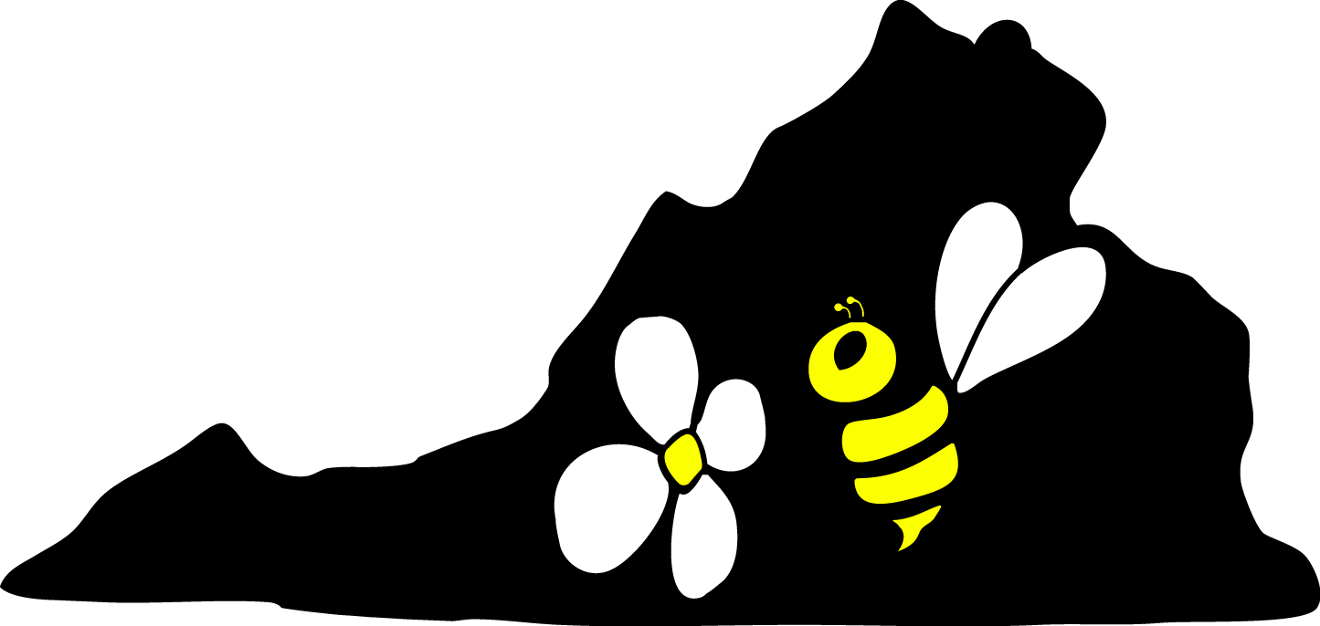

Beekeepers Association

Pres. Brian Gallagher - 978-4405 brian.j.gallagher@comcast.net
Treas. Art Freeman 540-456-6219 nameerftra@yahoo.com
Sec. Faith Andrews Bedford - 295-3823 faithab@aol.com
County Fair Coord. Ken Hall - 973-0807 kenneth.b.hall@gmail.com
Events Coord. Dana Tornabene - 974-1431 dana.tornabene@gmail.com
Newsletter – Brian Gallagher

July 2009

July 18th Honey Tasting

This years tasting will be on Saturday, July 18 at Ivy Creek. Bring your honey or some exotic honey that you obtained on your travels. The tasting starts at 2:00 PM and we will wrap up at 4:00 PM.

Note that we will have 2 polarized light boxes so you can test your Albemarle County Fair entry. Bring your extracted honey in Classic or Queenline glass jars to see what’s in it.

See you at the Ivy Creek Natural Area on Saturday, July 18th at 2:00 PM.

Directions to Ivy Creek Natural Area: http://ivycreekfoundation.org/located.html

Programs

If you have ideas for meeting topics you would like to see covered, let Dana Tornabene know.

This Month’s Beekeeping

The nectar/honey flow is over for us. My scale hive has weighed the same (plus or minus 1 lb.) for the past two weeks. Don’t assume that your bees have enough food for them to make it through the summer. When you take off the honey supers, check the brood boxes and see how much honey stores remain. For those with new packages or NUCs this year, if you have kept feeding them you can extend the comb building. Once they stop building comb they will not restart until there is a natural nectar flow. Also, with whatever amount of comb they did build, you can’t assume they stored enough honey, check them about every 2-3 weeks through the fall.

The CVBA Clothing Logo Program

ORDER YOUR CVBA LOGO GARMENTS NOW

At last month's meeting, Emma showed off our new logo, sampled on a polo shirt. Everyone loved it!!
Now you can have a logo’d garment, by printing, filling out, and mailing the
attached form, with a check made out to Art Freeman, to Art at 8799 Rockfish Gap Turnpike, Afton, VA 22920.

Forms must be in Art's hands by Friday, July 10, so the garments will be
ready for the Albemarle County fair.

2009 Albemarle County Fair – 28th Annual Event

The 28th annual Albemarle County Fair is scheduled for Tuesday July 28 through Sunday August 2. For those of you who are new to the Central Virginia Beekeepers - West club, the Albemarle County Fair is the main public event we undertake each year. Our mission at the fair is to educate the public at large about the value of Beekeeping, and hopefully get some visitors interested to the point that they actually become beekeepers.
Though outreach is our mission, we also have a friendly competition for “bragging rights” for the blue ribbon awarded to a variety of honey and wax products. This competition introduces fair visitors to some of the products we get directly from the bees and shows there is interest in the hobby in our area. But this only works when we have entries for people to see! You can enter items into the fair whether or not you live in either Albemarle County or the city of Charlottesville -- entries from throughout the region are accepted and encouraged. At the conclusion of the fair each entrant will get their judging sheet which will document exactly what the judge saw, including moisture content. Excessive moisture will cause honey to ferment, and a good refractometer for measuring moisture is expensive! By entering honey into the fair you will get a moisture analysis performed by an expert for free – not a bad trade for entering. A catalog describing the entries for all fair departments, including honey, is now available. Copies can usually be found at a number of public places, including the county libraries. It can also be found online at http://www.albemarlecountyfair.com. In brief, here are the classes of entries for the honey department; all entries must be from your 2009 harvest:
- Liquid honey – two 1-lb glass containers
- Chunk honey – two pint glass containers
- Cut comb honey – two containers
- Section comb honey – two sections
- Creamed honey – two creamed honey containers
- Beeswax – two identical castings any size
- Beeswax candles – two identical candles any size

All entries will need to be entered into the fair on Monday evening, July 27, at the North Garden fairgrounds, 4:30 - 7:30 PM. If you would like to enter but cannot get to the fair during that time, please contact me and I’ll see if I can arrange for someone to get your entries there on your behalf. Note that the competition is divided up into two divisions – a junior division for entrants 18 years of age or younger as of July 28 and an open division for all the rest of us. We have had several new younger members join the club in the past couple of years, so I hope to see additional junior entrants this year.
I encourage everyone to bottle their liquid honey entries at least one full week before the fair. It takes time for air bubbles to work their way out of the honey, and the presence of air bubbles leads to a deduction in judging points. For those of you attending the July 18th honey-tasting event, Brian and I will bring our polarized light boxes that are of the same design the judge will use during the judging process. If you bring sample jars of your honey you will be able to use the polarized light boxes to check out your honey ahead of the fair judging. Also, I will have sample-judging sheets there for you to see if you are interested. If you can’t make it out to the Fairgrounds on that Monday evening, and you are willing to trust Brian with your prize winning entries, bring them to the honey-tasting event and he’ll take care of you…
Throughout the fair we need volunteers to staff the booth, answering questions (of which there will be many) and promoting the benefits of the hobby. We will have a number of exhibits demonstrating various aspects of Beekeeping and will hand out honey samples and candy (for “kids” of all ages). In addition, the club provides a beehive in a screened cage where we do regular beekeeping demonstrations. We do NOT sell any honey products at the fair – our efforts are only for informative and educational purposes. I’m sure some of the new beekeepers are thinking “But I don’t know enough about bees yet to help out.” – not true!! Even if your experience is limited to only a few months, you now know more about Beekeeping than 99% of the people you will talk to. We always ensure that someone helping out with the fair for the first time is paired up with a fair “veteran”, so don’t be concerned about not knowing what to do. There is always a minimum of two members scheduled for each shift, ensuring that you can take breaks as you need. I will have sign-up sheets at the honey-tasting event, or contact me either via email at Kenneth.B.Hall@gmail.com or by phone at 434/973-0807 to volunteer. I will solicit the club members in the coming weeks to cover time slots that still lack sufficient coverage. Here is the list of time-slots so you can be thinking about it:
Tuesday July 28 4:00 – 9:00
Wednesday July 29 4:00 – 9:00
Thursday July 30 4:00 – 9:00
Friday July 31 4:00 – 9:00
Saturday August 1 10:00 – 2:00
Saturday August 1 1:00 – 5:00
Saturday August 1 5:00 – 9:00
Sunday August 2 1:00 – 6:00

Here’s hoping for a rain-free fair this year…
Thanks,
Ken Hall

CCD Article

A story on CCD appeared in the April Scientific American. Here’s the link:
Solving the Mystery of the Vanishing Bees: Scientific American

Natural Sugar Source

The Crozet Natural Foods Co-op purchases sugar in bulk. If you are looking for Natural or Organic sugar for feeding you might want to contact them regarding purchasing some. Their website is http://groups.yahoo.com/group/CrozetCo-op/

Honey Extractors

The CVBA has 2 extractors that members may borrow. They both have a stand to raise them so that a bucket may be placed under the drain to collect the honey. They also include an electrically heated uncapping knife. To borrow one call:

Four frame - contact Art Freeman (540-456-6219) to arrange to borrow it

Ten frame - contact Wayne Peterson (434-985-1902) to arrange to borrow it.

Please do not pass it on to anyone without checking with Art or Wayne as they maintain the list of the order of requests.

Contacts

Our Bee Experts that you might want to contact at times are:

Keith Tignor, State Apiarist, Richmond, 804-786-3515 Keith.Tignor@vdacs.virginia.gov

John McGhee, Bee Inspector, Harrisonburg, 540-209-9153
John.McGhee@vdacs.virginia.gov

A Beekeeper’s Calendar

So that you can mark your calendar ahead, and keep the following dates free for these important happenings, we’re going to include this calendar with every newsletter. More detailed announcements will be included in each month’s edition. The meetings of the CVBA are on the first Thursday of the month at Ivy Creek Natural Area at 7:00 PM, unless announced otherwise, from March through November.

July 18 - Annual Honey Tasting, Saturday at Ivy Creek (No July Meeting)
(Club members only)

July 27 - Bring Honey entries to the County Fair

July 28 - Aug 2 - Albemarle County Fair
http://www.albemarlecountyfair.com/

Aug 3-7 - Eastern Apicultural Society meeting, Ellicottville, NY
http://www.easternapiculture.org/

Aug. 6 - No Meeting because of the County Fair

Sept. 3 - CVBA Meeting at Ivy Creek Natural Area, 7:00 PM

Nov. 7 - VSBA Fall Meeting, Blue Ridge Com. College, Weyers Cave, VA
http://www.virginiabeekeepers.org/

Hope to see all of you at a meeting soon.

